JOB HUB • FEATURE & ARCHITECTURE CHANGELOG
Profile Module Upgrades & New Features Report
Detailed summary of all new profile features, bug fixes, API integrations, and launcher improvements committed to Nadim and main without altering the backend architecture.
1. Overview & Repository Summary
The Profile module (/profile) was expanded to expose and connect all existing backend capabilities in JobSeekerProfile, RecruiterProfile, NotificationPreference, and the hybrid AI matching engine (matching_service.py). Zero database schema migrations or breaking API changes were required—every new UI feature binds cleanly to existing FastAPI endpoints.
Attribute | Details
Commit Hash & Message | 61ddd3b — feat(profile): add experience, projects, certifications, preferences, and alert channels
Branches Updated | Nadim (https://github.com/Saif-AlSaad/JobHub/tree/Nadim) and main (fast-forward merge)
Files Changed | 7 files committed (2 new React components, 2 updated frontend files, 3 Windows batch launchers)
Architecture Impact | 100% backward compatible — reuses existing FastAPI routes, SQLAlchemy models, and Pydantic schemas
2. File-by-File Change Inventory
File Path | Type | Purpose & Summary of Changes
frontend/src/components/ProfileCareerRecords.jsx | Created (306 lines) | Reusable schema-driven CRUD component for Work/Internship Experience, Portfolio Projects, and Certifications.
frontend/src/components/ProfilePreferencesCard.jsx | Created (252 lines) | Career & AI match preferences (employment types, target roles, min match score) plus Email & In-App notification toggles.
frontend/src/pages/ProfilePage.jsx | Modified | Added section tabs, Phone & Graduation Year, 255-char Headline, Resume download link, Unsaved Changes badge, live readiness score, user-scoped avatar caching, and Recruiter hub sync.
frontend/src/services/api.js | Modified | Added offline/GitHub Pages mock fallback support for /notifications/preferences (GET/PUT) and profile PUT persistence.
start-all.bat, run-backend.bat, run-frontend.bat | Modified | Added directory-safe cd /d "%~dp0...", conditional venv activation, and auto-launch of http://localhost:5173.
3. Detailed Breakdown of New Features
3.1 Work Experience, Portfolio Projects & Certifications (ProfileCareerRecords.jsx)
Previously, the backend stored experience, projects, and certifications JSON arrays in JobSeekerProfile and scored them inside compute_hybrid_match(), but ProfilePage.jsx offered no UI to view or edit them. A single parameterized component (SECTION_CONFIGS) now manages all three uniformly:
- Work & Internship Experience: Inline Add / Edit / Delete forms for Role Title, Company / Organization, Duration, and Key Responsibilities. Directly boosts the AI Education & Experience score.
- Portfolio & Capstone Projects: Supports Project Title, Repository / Live URL (rendered as a clickable external link), comma-separated Tech Stack (converted cleanly into badge chips), and Project Summary. Having 2+ projects unlocks the backend AI portfolio bonus.
- Certifications & Credentials: Supports Certification Name, Issuing Organization (e.g., Coursera, AWS), and Year Earned.
- Uniform Entry Actions: Each card displays an entry count pill, inline editing via Pencil icon, deletion via Trash icon, and clean empty-state prompts.
3.2 Career & AI Match Preferences + Notification Channels (ProfilePreferencesCard.jsx)
- Preferred Employment Types (Seekers): Multi-select toggle pills for Internship, Full-time, Part-time, and Remote. Synced with preferred_job_types, which controls the job-type alignment bonus in matching_service.py.
- Target Job Roles (Seekers): Interactive role tag input with Enter-key support, removal buttons, and one-click suggestions (Software Engineer, Backend Developer, Frontend Developer, Full-Stack Developer, AI / ML Engineer, DevOps Engineer).
- Minimum Match Alert Threshold (Seekers): Quick preset selector (50%, 60%, 70%, 80%, 90%) synced across both JobSeekerProfile.min_match_score and NotificationPreference.min_match_score.
- Notification Delivery Channels (Seekers & Recruiters): Checkboxes for Email Digest & Match Alerts (email_alerts) and In-App Real-Time Alerts (in_app_alerts), loaded from and saved to /api/v1/notifications/preferences.
3.3 Profile Page Enhancements & Bug Fixes (ProfilePage.jsx)
- New Candidate Credential Fields: Added Phone / WhatsApp input and editable Graduation Year input (replacing the previously hardcoded 2026). Separated Headline from bio with a 255-character counter matching the SQLAlchemy String(255) column.
- Resume Download / View Action: When resume_url exists on the profile, a Download button appears next to the Active Document badge pointing to the FastAPI static /uploads mount.
- Section Navigation Pill Tabs: Added a responsive tab bar below the hero banner (All Sections, Credentials & Skills, Experience & Projects, Matching & Alerts for Seekers; All Sections, Company & Stack, Radar & Alerts for Recruiters) with live item counts.
- Unsaved Changes Indicator & Parallel Save: Tracks form dirtiness (isDirty) and displays an 'Unsaved changes' pill near the Save CTA. Clicking Save persists both /seekers/profile (or /recruiter/profile) and /notifications/preferences concurrently via Promise.all.
- Synced Placement Readiness Score: Updated computeReadinessScore() to mirror the backend /seekers/dashboard-summary formula (base 30% + 20% for 4+ skills + 15% for education + 15% for 1+ project + 10% for 1+ experience + 10% for resume/avatar).
- User-Scoped Avatar Cache Fix: Replaced the global jobhub_user_avatar key with a user-scoped key (jobhub_user_avatar_${user?.id || user?.role}) and prioritized server avatar_url first, preventing one account's photo from bleeding into another when switching roles.
- Recruiter Hub & Founded Year Fix: Wired the Recruiter Company Office / Hiring Anchor Hub selector to read company.location_name and persist company_location via PUT /recruiter/profile, and displayed company_founded_year (e.g., Est. 2018) in the hero card.
3.4 Offline Fallback & Windows Launchers (api.js & .bat files)
- Mock Fallback Route Ordering & Persistence (api.js): Added dedicated /notifications/preferences GET/PUT handling before the generic /notifications check, and enabled localStorage persistence for PUT /seekers/profile and PUT /recruiter/profile in static/offline preview mode.
- Windows Launcher Reliability (.bat files): Updated start-all.bat, run-backend.bat, and run-frontend.bat to use cd /d "%~dp0...", check if venv\Scripts\activate.bat exists before calling it, and open http://localhost:5173 automatically.
4. Backend-to-Frontend Integration Matrix
New UI Feature | Backend Endpoint | Model / Column | AI Matching / System Effect
Experience & Projects | GET/PUT /seekers/profile | JobSeekerProfile.experience, projects | Feeds TF-IDF semantic doc & exp_edu_score (+5% for 2+ projects)
Certifications | GET/PUT /seekers/profile | JobSeekerProfile.certifications | Stored as structured JSON credential cards
Phone & Graduation Year | GET/PUT /seekers/profile | JobSeekerProfile.phone, education[0].graduation_year | Replaces hardcoded 2026; populates contact info
Job Types & Target Roles | GET/PUT /seekers/profile | preferred_job_types, preferred_roles | Controls job-type match bonus (+5 / -10 pts) in matching_service.py
Min Match Score & Alert Toggles | GET/PUT /notifications/preferences | NotificationPreference.min_match_score, email_alerts, in_app_alerts | Filters smart placement alerts & delivery channels
Resume Download Button | GET /uploads/{filename} | JobSeekerProfile.resume_url | Serves uploaded PDF/DOCX via FastAPI StaticFiles
Recruiter Hub & Founded Year | GET/PUT /recruiter/profile | Company.location_name, founded_year | Syncs office hub selection and displays founding year
5. Build, Lint & Live Browser Verification
- Production Vite Build: Executed npm run build in frontend/ — succeeded with exit code 0 (1984 modules transformed in 12.22s).
- Oxlint Static Analysis: Executed npx oxlint across ProfilePage.jsx, ProfileCareerRecords.jsx, ProfilePreferencesCard.jsx, and api.js — 0 errors reported (0 warnings on both new components).
- Playwright End-to-End Check: Verified live against http://localhost:5173 and http://localhost:8000: Seeker profile (Sarah Rahman) loaded all seeded records, toggled '+ Remote', saved via PUT /seekers/profile and PUT /notifications/preferences ('Profile Updated Successfully'), and Recruiter profile (Tanvir Ahmed / TechNova Labs) loaded cleanly with zero new console errors.
6. Updated Profile Page Visual Preview
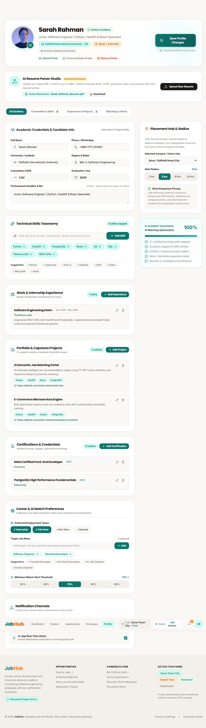
Figure 1: Upgraded Job Seeker Profile (/profile) showing Section Tabs, Resume Download, Phone & Graduation Year, Experience, Projects, Certifications, Career Preferences, and Notification Channels.

